Planning and Deploying a Stand-Alone Primary Site
Planning a System Center Configuration Manager Stand-Alone Primary Site Deployment
Planning a System Center Configuration Manager (SCCM) stand-alone primary site deployment is a crucial step for a successful implementation. A stand-alone primary site is a good choice for smaller to medium-sized environments and can be expanded later if needed.
Here are the key steps and considerations for planning your deployment:
1. Define Your Environment and Requirements
Before you begin, you need to have a clear understanding of your environment and what you want to achieve with SCCM.
- Determine Hierarchy: Decide whether a stand-alone primary site is sufficient. A stand-alone primary site can manage up to 175,000 clients and devices, but if you anticipate needing more than that or have a very complex, geographically dispersed network, you might need to consider a hierarchy with a Central Administration Site (CAS) later on. It is generally recommended to start with a standalone primary site and expand it into a hierarchy if needed.
- Identify Managed Devices: Determine the number and type of devices you will manage, including Windows clients, macOS devices, and mobile devices. This will help you estimate hardware requirements.
- Identify Required Features: Plan which SCCM features you will use, such as Operating System Deployment (OSD), software updates, or application management. This will dictate which site system roles you need to install.
2. Hardware and Software Prerequisites
- Server Hardware: Ensure your server meets the recommended hardware specifications for your expected client load. A standalone primary site can manage up to 50,000 clients if the site server and site database roles are on the same server, and up to 100,000 clients if they are on separate servers. The performance of your server, especially the disk I/O, is critical.
- Operating System: Install a supported 64-bit version of Windows Server.
- SQL Server: SCCM requires a supported version of SQL Server to host the site database. You can install SQL Server on the same machine as the primary site server or on a separate server. For best performance, use dedicated drives for SQL databases and logs.
- Windows ADK: Download and install the Windows Assessment and Deployment Kit (ADK) and the Windows Preinstallation Environment (PE) add-on. Make sure the version of the ADK you use is compatible with your SCCM version.
- Server Roles and Features: Install necessary Windows roles and features, including .NET Framework, Remote Differential Compression (RDC), and Internet Information Services (IIS).
3. Active Directory Preparation
- Extend the Schema: Extending the Active Directory schema is highly recommended. It allows SCCM to publish information to Active Directory, making it easier for clients to find management points and other site resources.
- Create a System Management Container: SCCM does not automatically create this container. You must manually create a System Management container in Active Directory and grant the primary site server's computer account Full Control permissions to the container and all descendant objects.
- Service Accounts: Create and document the necessary service accounts for different SCCM roles, such as the Network Access Account, SQL service account, and a client push installation account.
4. Naming and Configuration
- Site Code and Name: Choose a three-character alphanumeric site code that is unique within your organization. You cannot change this after installation.
- Firewall Ports: Plan to configure your firewall to allow the necessary communication ports between SCCM site systems, clients, and other network services.
- Boundaries and Boundary Groups: Plan your boundaries and boundary groups. Boundaries are network locations (e.g., IP subnets, Active Directory sites, IP address ranges) that contain managed clients. Boundary groups link these boundaries to site systems, allowing clients to find management points and distribution points.
For a visual guide on the prerequisites and installation, you can watch this video on installing prerequisites for Configuration Manager step by step.

Active directory schema
The Active Directory schema is the blueprint for all objects and their attributes within an Active Directory forest. It defines the classes of objects that can be created (like users, computers, and groups) and the attributes that those objects can have (e.g., a user's name, email, and phone number).

Extending the Active Directory schema
Extending the Active Directory schema is the process of adding new object classes and attributes to this blueprint. For System Center Configuration Manager (SCCM), this is a critical step because it allows the SCCM site server to publish important information about its resources (like management points and site boundaries) to Active Directory. This makes it easier for clients to discover and communicate with the site infrastructure without requiring manual configuration.

The schema extension process is permanent and cannot be reversed. However, it is designed to be a safe operation, and Microsoft provides the extadsch.exe utility to perform this task automatically. The user account running this utility must have Schema Admins permissions in the Active Directory domain to successfully modify the schema. This action only needs to be performed once per domain.

Extending the Active Directory schema for a System Center Configuration Manager (SCCM) deployment involves a few key steps to ensure the site server can publish information correctly.
Safety note: Schema changes are forest-wide and additive (you can’t roll them back). The tool is designed to be safe and is typically non-disruptive, but always perform during a maintenance window if possible.
Here is the process:
- Grant Permissions: The user account you are logged in with must be a member of the Schema Admins security group. This is a prerequisite for running the schema extension utility.
- Locate the Tool: On the SCCM installation media, navigate to the SMSSETUP\BIN\X64 folder.
Examples: C:\Program Files\Microsoft Configuration Manager\cd.latest\SMSSETUP\BIN\X64.
- Run the Utility: From an elevated command prompt, execute the following command: extadsch.exe.
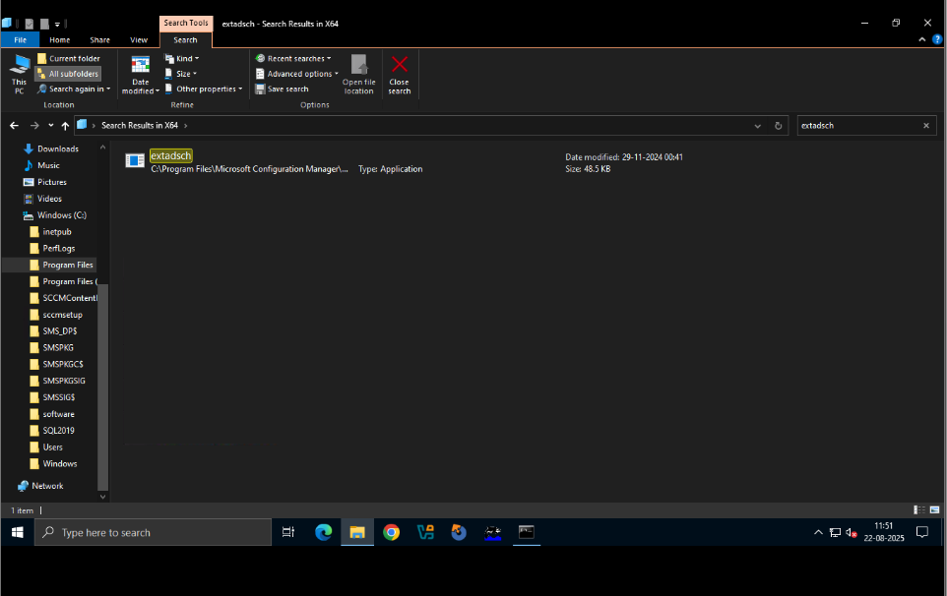
--Open an Elevated Console
- Open Command Prompt or PowerShell Run as Administrator.
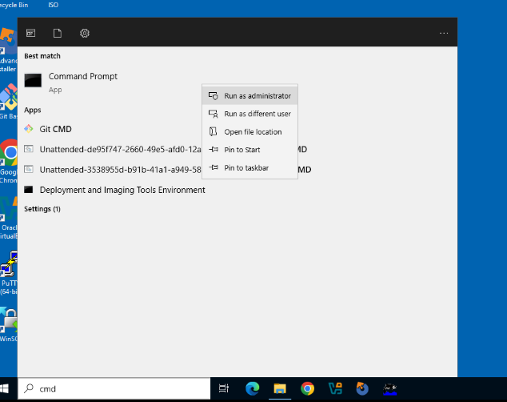
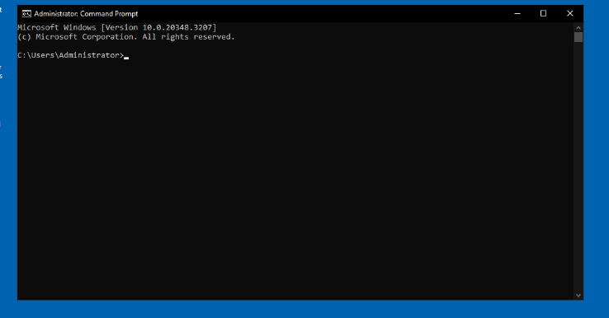
— Navigate to the X64 Folder on the Media
- CMD:
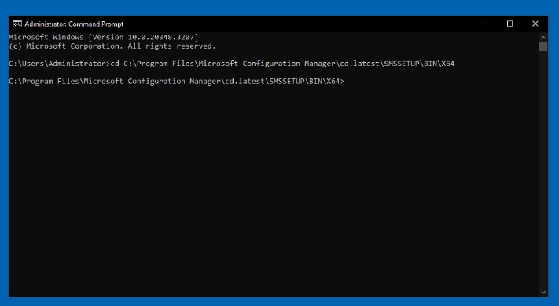
— Run the Schema Extension
- CMD:
- extadsch.exe
- If prompted by UAC, click Yes.
- The tool runs quickly and writes a log to the system drive.
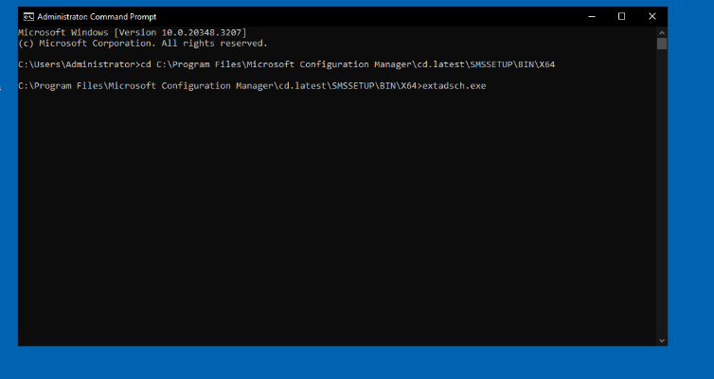
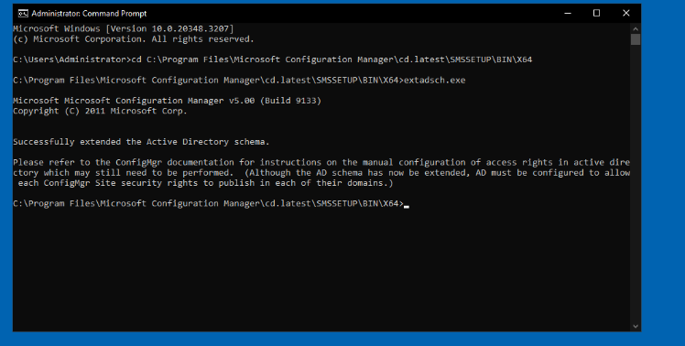
- Verify the Log (C:\ExtADSch.log)
Verify Success: Check the Extadsch.log file, located in the root of the system drive, to confirm that the schema extension completed successfully. The log file will indicate the result of the process.
This process only needs to be performed once for each domain that will have a primary or secondary site server publishing to Active Directory.
- Open the log file from the root of your system drive (usually C:):
- notepad C:\ExtADSch.log
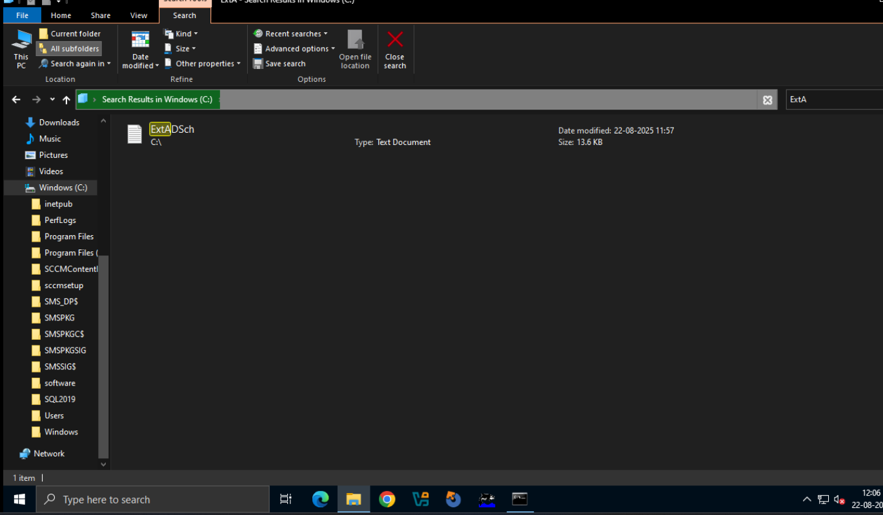
- Confirm it contains a success entry like:
- Successfully extended the Active Directory schema.
- Common informational lines include classes/attributes added; warnings may indicate objects already exist (that can be normal if the schema was extended previously).
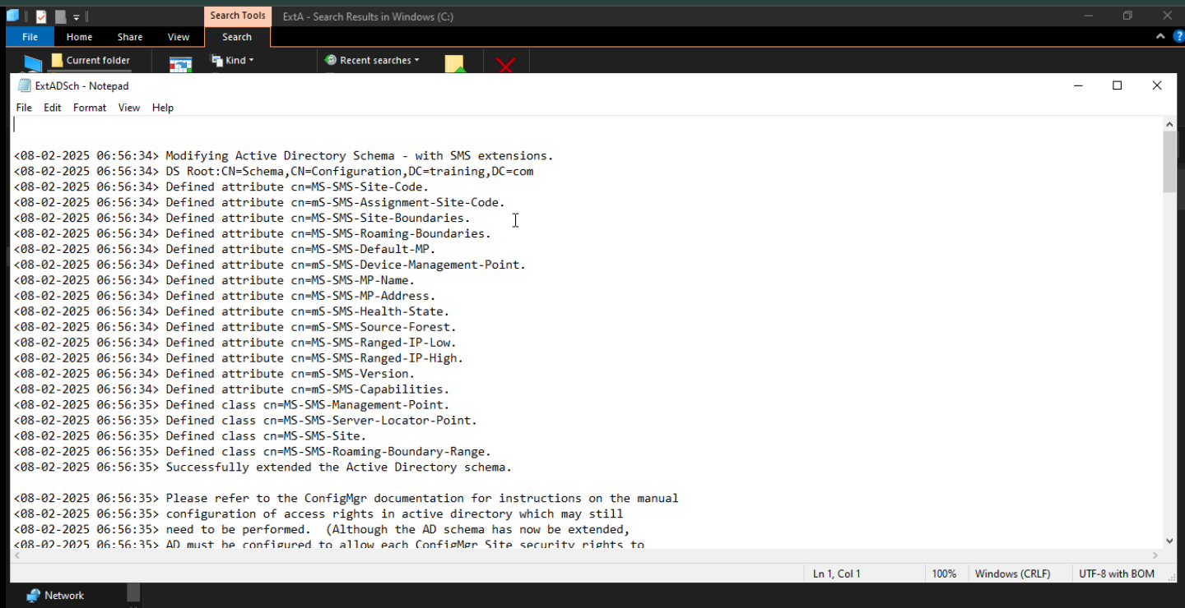

Installing a Configuration Manager Site Server
Installing a Configuration Manager (ConfigMgr) site server is the process of setting up the central administration point for your SCCM environment. This server hosts the core services and roles that manage your devices, software, and configuration settings. A stand-alone primary site server is a self-sufficient management point that can be scaled up later if your organization grows. The installation process involves running a setup wizard that guides you through configuring the site's unique identity, connecting to a SQL database, and defining the initial roles.
Key Components and Sub-topics
The installation is not just about clicking "Next." It involves several critical steps that must be completed in order:
- Prerequisite Installation: Before you can even start the main setup, you must have all the necessary software and server roles installed. This includes a supported version of Windows Server and SQL Server, as well as the Windows ADK and other Windows features like IIS and BITS.
- Active Directory Preparation: For full functionality, you must prepare your Active Directory by extending the schema and creating the "System Management" container. This enables clients to discover the site automatically.
- Setup Wizard Configuration: During the installation, you must make key decisions:
  - Site Code and Name: You will define a unique three-character site code and a descriptive site name. These are permanent and cannot be changed later.
  - Database Information: You will specify the SQL Server instance where the site database will be hosted.
  - Initial Site Roles: The setup can automatically install the core site roles, such as the management point and distribution point, on the site server itself.
Official Documentation
Use the setup wizard to install a central administration or primary site

Updates and Servicing
Updates and Servicing is a feature in Microsoft Configuration Manager (formerly SCCM) that provides a streamlined, in-console method for keeping your Configuration Manager infrastructure up to date. It's a significant change from the traditional approach of manually downloading and installing service packs, cumulative updates, and hotfixes.
Practical Overview:
- In-Console Experience: Instead of going to a website to find and download updates, all available updates are presented directly within the Configuration Manager console under the Administration > Updates and Servicing node.
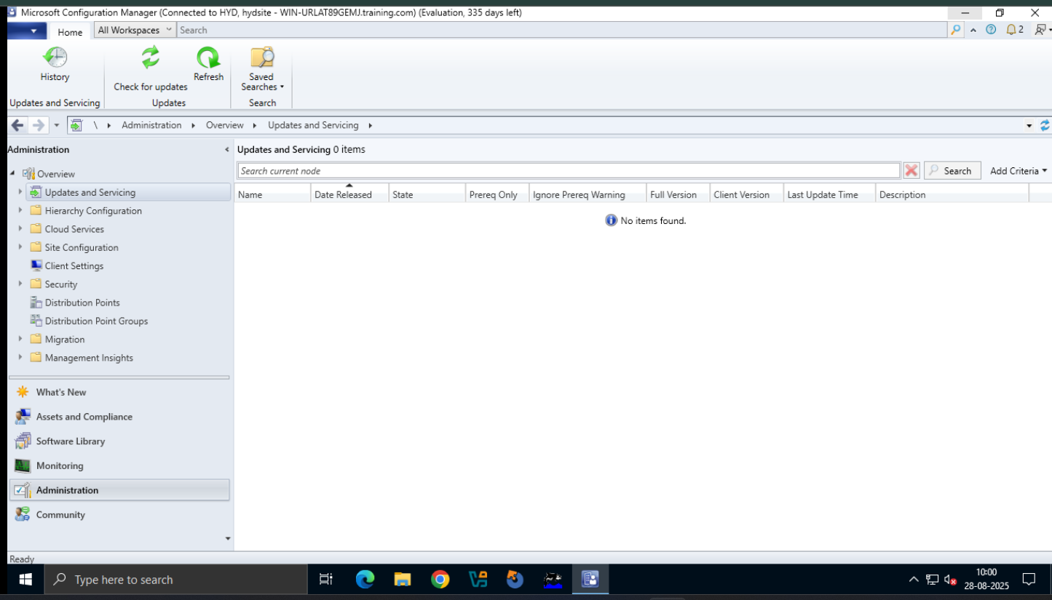
- Targeted Updates: The system only shows updates that are relevant to your specific environment, based on the version of Configuration Manager you are running and the telemetry data you are uploading to Microsoft.
- Simplified Process: The process typically involves a simple right-click and selection of "Install Update Pack." Configuration Manager handles the download, prerequisite checks, and installation for you.
- Hierarchy-Wide Updates: When you install an update at the top-level site (Central Administration Site or a stand-alone primary site), the update automatically replicates to child primary sites. Secondary sites, however, must be updated manually.
- Prerequisite Checks: Before a major update, Configuration Manager runs a prerequisite check to ensure your environment is ready. This helps prevent installation failures and ensures a smoother upgrade experience.
- CD.Latest Folder: After an update, Configuration Manager creates a new folder on the site server called CD.Latest. This folder contains the updated installation files, which are essential for site recovery or for installing new sites in a hierarchy that has been updated.
Service Connection Point (SCP)
The Service Connection Point (SCP) is a critical site system role in a Configuration Manager hierarchy. It acts as the gateway between your on-premises Configuration Manager environment and Microsoft's cloud services.
Key Functions of the SCP:
- Downloads Updates: The SCP is responsible for connecting to the Microsoft cloud to check for and download new updates for your Configuration Manager infrastructure. It's the engine behind the "Updates and Servicing" feature.
- Uploads Usage Data: It uploads telemetry and usage data from your Configuration Manager environment to Microsoft. This data is used by Microsoft to provide you with the correct and most relevant updates. You have control over the level of data that is uploaded.
- Cloud Services Integration: The SCP is a prerequisite for a variety of cloud-connected features, such as:
  - Cloud Management Gateway (CMG): A cloud-based service that allows you to manage internet-based clients.
  - Tenant Attach: A feature that integrates your Configuration Manager environment with Microsoft Intune for co-management and other cloud-based services.
  - Microsoft Store for Business and Education: Synchronizing apps from the Microsoft Store.
Practical Overview:
- Single Instance: You can only have one SCP role in a Configuration Manager hierarchy. It must be installed at the top-tier site (a Central Administration Site or a stand-alone primary site).
- Network Requirements: The server hosting the SCP requires internet access to communicate with Microsoft's cloud services on HTTPS port 443. You may need to configure firewall and proxy server settings to allow this communication.
SCP Modes of Operation
The Service Connection Point has two primary modes of operation, which determine how it connects to the Microsoft cloud:
- Online, persistent connection (Recommended):
  - How it Works: This is the default and recommended mode. The SCP automatically connects to the Microsoft cloud services on a daily basis (every 24 hours) to check for updates.
  - Advantages: This mode is the most convenient and ensures your Configuration Manager hierarchy is kept up-to-date with the latest features, fixes, and security patches without manual intervention.
  - Disadvantages: Requires a persistent internet connection on the server hosting the SCP.
- Offline, on-demand connection:
  - How it Works: In this mode, the SCP does not connect to the Microsoft cloud. Instead, you must use a separate command-line tool called the Service Connection Tool to manually perform the update and telemetry synchronization.
  - Practical Steps:
    - Prepare: Run the tool on the SCP server to export a .cab file containing your usage data.
    - Connect: Copy the .cab file to a computer with internet access and run the tool again to upload the data to Microsoft and download the updates.
    - Import: Copy the downloaded updates back to the SCP server and run the tool one last time to import the updates into your Configuration Manager console.
  - Advantages: Ideal for highly secure environments that do not allow the site server to have direct internet access.
  - Disadvantages: This is a manual and multi-step process that requires more administrative effort to keep your environment current.

